**CS224 - Spring 2022 - Lab #4**

**MIPS Single-Cycle Datapath and Controller**

**Dates**:

Section 1: Mon, 4 Apr, 8:30-12:20 in EA-Z04   
Section 2: Wed, 6 Apr, 13:30-17:20 in EA-Z04   
Section 3: Tue, 5 Apr, 13:30-17:20 in EA-Z04   
Section 4: Fri, 8 Apr, 08:30-12:20 in EA-Z04

Section 5: Wed, 6 Apr, 8:30-12:20 in EA-Z04   
Section 6: Fri, 8 Apr, 13:30-17:20 in EA-Z04

**Lab 5 Days**:

Due to the lab rotation policy the first Lab5 session will be with Section 2 and Section 5 on Wednesday (April 13). After them Section 4 and Section 6 will do their labs on Friday (April 15). Sections 1 and 3 will do their labs in the week of April 18 on their respective lab days. See the course syllabus for the lab days.

**TAs:**

Section 1:  Pouya Ghahramanian, Pouria Hasani; Fazıl Keskin  
Section 2:  Alper Şahıstan, Hüseyin Eren Çalık; Burak Öçalan  
Section 3:  Kemal Büyükkaya, Kenan Çağrı Hırlak

Section 4: Pouria Hasani, Sepehr Bakhshi

Section 5: Kenan Çağrı Hırlak, Soheil Abadifard; Alper Mumcular

Section 6: Alper Şahıstan, Soheil Abadifard

**TA name (x No of labs): email address**

Alper Şahıstan (x2): alper.sahistan@bilkent.edu.tr

Hüseyin Eren Çalık (x1): eren.calik@bilkent.edu.tr

Kemal Büyükkaya (x1): kemal.buyukkaya@bilkent.edu.tr

Kenan Çağrı Hırlak (x2): cagri.hirlak@bilkent.edu.tr

Pouria Hasani (x2): pouria.hasani@bilkent.edu.tr

Pouya Ghahramanian (x1): ghahramanian@bilkent.edu.tr

Sepehr Bakhshi (x1): sepehr.bakhshi@bilkent.edu.tr

Soheil Abadifard (x2): soheil.abadifard@bilkent.edu.tr

**Tutor name (x No of labs): email address**

Alper Mumcular (x1): alper.mumcular@ug.bilkent.edu.tr

Burak Öçalan (x1): burak.ocalan@ug.bilkent.edu.tr (Tutoring in the lab Thursdays, 6:15 - 8:00 pm)

Fazıl Keskin (x1): fazil.keskin@ug.bilkent.edu.tr

**Purpose**: In this lab you will use the digital design engineering tools (System Verilog HDL, Xilinx Vivado and FPGA, Digilent BASYS3 development board) to modify the single-cycle MIPS processor. You will expand the instruction set of the “MIPS-lite” processor by adding new instructions to it. To do this, you must first determine the RTL expressions of the new instructions then modify the datapath and control unit of the MIPS. Implementing the new instructions will require you to modify some System Verilog modules in the HDL model of the processor. To test and prove correctness, you will first simulate the microarchitecture, then synthesize it and demonstrate on the BASYS3 board.

**Summary**

**Part 1 (50 points):** SystemVerilog model for Original10, Presenting RTL instructions, datapath and controller changes for the new instructions assigned to your section,

**Part 2 (50 points):** Simulation of the MIPS-lite processor and Implementation and Testing of the new instructions assigned to your section.

**[REMINDER!]** In this lab and the next one, we assume SystemVerilog knowledge, since you all took CS223 – Digital Design. If you are not familiar with these, please get used to them as soon as possible

Note try, study, and aim to complete lab part at home before coming to the online lab.

**DUE DATE OF PART 1 & 2 (PRELIMINARY WORK): SAME FOR ALL SECTIONS**

**No late submission will be accepted**.

**a.** Please upload your programs of preliminary work to Moodle by 9:30 am on Monday, Apr 4th.

**b.** Please note that the Moodle submission closes sharp at 9:30 am and no late submissions will be accepted. You can make resubmissions before the system closes, so do not wait the last moment. Submit your work earlier and change your submitted work if necessary. Note that only the last submission will be graded.

**c.** Do not send your work by email attachment they will not be processed. They have to be in the Moodle system to be processed.

**e.** For the report, use filename **StudentID_FirstName_LastName_SecNo_PRELIM_LabNo_Report.pdf** Only a PDF (pdf file) is accepted. Any other form of submission receives 0 (zero).

**DUE DATE PART 3 (LAB WORK): (different for each section) YOUR LAB**

1. You have to demonstrate your lab work to your TA for grading. Do this by **12:00** in the morning lab and by **17:00** in the afternoon lab. Your TAs may give further instructions on this. If you wait idly and show your work last minute, your work may not be graded.
2. At the conclusion of the demo for getting your grade, you will **upload your Lab Work** to the Moodle Assignment, for similarity testing by MOSS. See below for the details of lab work submission.
3. Try to finish all of your lab work before coming to the lab, but make sure that you upload your work after making sure that it is analyzed by your TA and/or you are given the permission by your TA to upload.

**If we suspect that there is cheating we will send the work with the names of the students to the university disciplinary committee.**

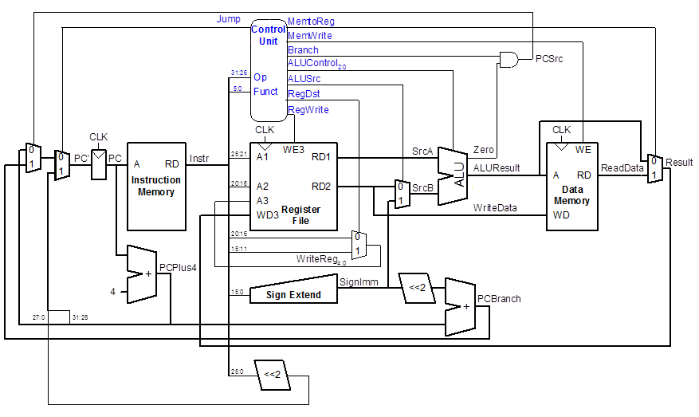Figure 1: Datapath for Original10

**Part 1 & 2. Preliminary Work (50 points)**

**For the preliminary work, you need to prepare a PDF file containing your answers to Part 1.a, 1.d, 1.e, 1.f and Part 2.**

Provide following five lines at the top of your submission for preliminary and lab work (make sure that you include the course no. CS224, important for ABET documentation).

CS224

Lab No.

Section No.

Your Full Name

Bilkent ID

Make sure that you identify what is what at the beginning of each program by using proper comments.

**Important Notes**

1. **Assume that all Inputs are Correct**. In all lab works, if it is not explicitly stated, you may assume that program inputs are correct.

| Instruction | Opcode | RegWrite | RegDst | ALUSrc | Branch | MemWrite | MemToReg | ALUOp | Jump |
| --- | --- | --- | --- | --- | --- | --- | --- | --- | --- |
| R-type | 000000 | 1 | 1 | 0 | 0 | 0 | 0 | 10 | 0 |
| lw | 100011 | 1 | 0 | 1 | 0 | 0 | 1 | 00 | 0 |
| sw | 101011 | 0 | X | 1 | 0 | 1 | X | 00 | 0 |
| beq | 000100 | 0 | X | 0 | 1 | 0 | X | 01 | 0 |
| addi | 001000 | 1 | 0 | 1 | 0 | 0 | 0 | 00 | 0 |
| j | 000010 | 0 | X | X | X | 0 | X | XX | 1 |

Table 1: Main Decoder for Original10

|  |  |  |
| --- | --- | --- |
| ALUOp | Funct | ALUControl |
| 00 | X | 010 (add) |
| 01 | X | 110 (subtract) |
| 1X | 100000 (add) | 010 (add) |
| 1X | 100010 (sub) | 110 (subtract) |
| 1X | 100100 (and) | 000 (and) |
| 1X | 100101 (or) | 001 (or) |
| 1X | 101010 (slt) | 111 (set less than) |

Table 2: ALU Decoder for Original10

**Part 1.**

1. **[3 Points]** Determine the assembly language equivalent of the machine codes given in the imem module in the “Complete MIPS model.txt” file posted on Moodle for this lab. In the given System Verilog module for imem, the hex values are the MIPS machine language instructions for a small test program. Dis-assemble these codes into the equivalent assembly language instructions and give a 3- column table for the program, with one line per instruction, containing its location, machine instruction (in hex) and its assembly language equivalent. [Note: you may do dis-assembly by hand or use a program tool.]
2. Make a new Vivado Project, giving it a meaningful name for your single-cycle MIPS-lite. Do Add Source for the SystemVerilog modules given in “Complete MIPS model.txt” and Save everything (you don’t have to use Complete MIPS model.txt, you can write your code if you find it more convenient). This file contains implementation of Original10 instructions in “MIPS-lite” which are the following: **add**, **sub**, **and**, **or**, **slt**, **lw**, **sw**, **beq**, **addi**, **j**.
3. Study the code and convince yourselves that the *datapath* module exactly corresponds to Figure 1 and *controller* module (including *maindec* and *aludec* modules)to Table 1 and Table 2. In the decoder tables, X means it is a “don’t care”. That is, it does not matter if it is 0 or 1.

1. **[7 Points]** Now make a SystemVerilog testbench file and using Xilinx Vivado, simulate your MIPS-lite processor executing the test program. In your testbench, do not forget to reset your processor at the beginning. Do not change the instructions in the imem module use it as is. Study the generated waveform. Find each instruction and understand its values. **Take a screenshot of the waveform and paste it to the report**. Do not include the reset time in your screenshot. Your waveform should be similar to the below image. Make sure that your output shows the exact same variables.

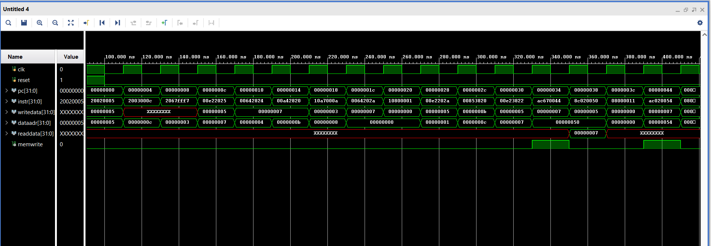Figure 2: Example Waveform

1. **[5 Points]** Make some observations on the waveform that you generated. These questions assume that you have used imem module as is without modifying any instruction there.
   1. In an R-type instruction what does writedata correspond to?
   2. Why is writedata undefined for some of the early instructions in the program?
   3. Why is readdata most of the time undefined?
   4. In an R-type instruction what does dataadr correspond to?
   5. In which instructions memwrite becomes 1?
2. **[5 Points]** Modify the alu module in “Complete MIPS model.txt” so that when alucont = 011, alu computes the result of a << b. Put the modified alu module in your report.

**Part 2**.

|  |  |
| --- | --- |
| Section | MIPS instructions |
| 1 | Base: Original10  New: “sracc” + “sw+” |
| 2 | Base: Original10  New: “sracc” + “subi” |
| 3 | Base: Original10  New: “sracc” + “jalm” |
| 4 | Base: Original10  New: “sracc” + “bge” |
| 5 | Base: Original10  New: “sracc” + “ble” |
| 6 | Base: Original10  New: “sracc” + “jm” |

Table 3: Section-wise distribution of the instructions

Instructions in quotes (e.g. “subi”) are not defined in the MIPS instruction set. They don’t exist in any MIPS documentation; they are completely new to MIPS. You will create them, according to the definitions below, then implement them. You may check “Samples of new instructions.txt” file to see example usages of new instructions.

**sracc:** this R-type instruction shifts the bits of RF[rs] to the right by a number of positions given in RF[rt]. Then, it increments RF[rd] by this value. Example: sracc $t0, $t1, $t2. **Hint:** To implement sracc, you might add a new read port to RF.

**subi**: this I-type instruction subtracts, using a sign-extended immediate value. Example: subi $t2, $t7, 4

**jm**: this I-type instruction is a jump, to the address stored in the memory location indicated in the standard way. Example: jm 40($s3)

**jalm**: this I-type instruction is a jump, to the address stored in the memory location indicated in the

standard way. But it also puts the return address into the register specified. Example: jalm $t5, 40($s3)

**bge**, **ble**: these I-type instructions do what you would expect—branch to the target address, if the condition is met. Otherwise, the branch is not taken. Example: bge $t2, $t7, TopLoop

**sw+**: this I-type instruction does the normal store, as expected, plus an increment (by 4, since it is a word transfer) of the base address in RF[rs]. {Note: these kind of auto-increment instructions are useful when moving through an array of data words.} Example: sw+ $t0, 4($t1)

1. **[3 Points]** Register Transfer Level -Language- (RTL) expressions for the new instructions that you are adding (see Table 3), including the fetch and the updating of the PC.
2. **[15 Points]** Make any additions or changes to the datapath which are needed in order to make the RTLs for the instructions possible. The base datapath should be in black, with changes for marked in red and other colors (one color per new instruction). **Make your changes on “Final Datapath.png” file.**
3. **[12 Points]** Make a new row in the main decoder table for each new instruction being added, and if necessary, add new columns for any new control signals that are needed (input or output). You can use any opcode value you want unless it conflicts with the existing opcodes in the Table 1. Be sure to completely fill in the table—all values must be specified. **Make your changes on Table 1: Main Decoder for Original10.** If any changes are needed in the ALU decoder table (Table 2), give this table in its new form (with new rows, columns, etc). The base table should be in black, with changes marked in red and other colors. {Note: if you need new ALUOp bits to encode new values, you should also give a new version of Table 2, showing the new encodings}

**Part 3. Lab Work (50 points)**

**Simulation of the MIPS-lite processor (25%)**

In this section, using your design in Part 2, you will extend the given MIPS processor with your new instructions (see Table 3).

**a**) Implement the modified processor by making the necessary changes to the System Verilog modules to support your new instructions. Integrate these all together into a new System Verilog model for the MIPS single-cycle processor that does the Original10 instructions plus the new instructions required for your section.

**b**) Then, using the testbench you have already written, simulate and test your extended MIPS processor. Write test codes for the new instructions you implemented, and verify that the new instructions, as well as the Original10, works correctly. **Hint:** You can extend the imem module for your tests.

When you have studied the simulation results and can explain, for any instruction, the values of PC, instruction, writedata, dataaddr, readdata and the memwrite signal, then call the TA, show your simulation demo and answer questions for grade.   The purpose of the questions is to determine your knowledge level and test your ability to explain your demo, the System Verilog code and the reasons behind it, and to see if you can explain what would happen if certain changes were made to it.  **To get full points from the Oral Quiz, you must know and understand everything about what you have done.**

**Implementation and Testing with BASYS3 (25%)**

In previous sections, you have designed and implemented an extension for MIPS-lite processor and simulated your design. In this section, by programming your implementation into BASYS3 FPGA, you will witness that your code represents a real working processor.

**a**) First, you should consider the following: BASYS3 has a default clock with 100 Mhz frequency. So, if you execute your test code with the default clock, the changes will not be observable. To slow down the execution to an observable rate, the clock signal should be hand-pushed, to be under user control. One clock pulse per push and release means one instruction is fetched-decoded-executed. Similarly the reset signal should be under hand-pushed user control. So these two inputs of the top module need to come from push buttons, and to be debounced and synchronized.

The memwrite output of the top module (along with any other control signals that you want to bring out for viewing) can go to a LED, but the other 32-bit outputs should go to the 7-segment display, in order to be viewed in a human-understandable way. As 7-segment is not large enough to display all these information, you should output PC and dataadr and convert the other 32-bit outputs to internal signals. Then, you should send the low-order bits of PC and dataadr to 7-segment display. [Consider why it isn’t necessary to see all 32 bits of these busses, just the low-order bits are enough.]

In view of the above, create a new top-level System Verilog module, to model the system that contains an instantiation of the MIPS computer (in module top), as well as 2 instantiations of pulse_controller module (for hand-pushed clock and reset signals), and 1 instantiation of display_controller module (to display values in 7-segment display). You can find these modules under the lab folder. **Hint:** You will find most of the information you need in header comments of the modules.

Your system should include some hand-pushed signals coming from push buttons, and some anode and cathode outputs going to the 7-segment display unit on the BASYS3 board and memwrite (and possibly other outputs) going to a LED.

**b**) Make the constraint file that maps the inputs and outputs of your top-level System Verilog model to the inputs (100 Mhz clock and pushbutton switches) and outputs (AN, SEG and DP signals to the 7-segment display, and memwrite going to a LED) of the BASYS3 board and its FPGA.

**c**) Now program your implementation on the BASYS3 board, and test it. Make sure that the values displayed on BASYS3 are the same as the ones you obtained during simulations. When both of your new instructions are working correctly in hardware, and all 10 of the old instructions are also still working, call the TA and show it for grade. *Note: the TA will ask questions to you, in a single 25-point demo and Oral Quiz,* to determine how much of the 25 points for this part of Part 3 (implementation) is deserved, based on your demo, your knowledge and ability to explain it and the System Verilog code and the reasons behind it, and what would happen if certain changes were made to it. **To get full points from the Oral Quiz, you must know and understand everything about what you have done.**

**Aim to complete lab part at home before coming to the online lab.**

**Part 6. Submit Your Code for MOSS Similarity Testing**

1. Submit your Lab Work MIPS codes for similarity testing to Moodle.
2. You will upload one file. Use filename **StudentID_FirstName_LastName_SecNo_LAB_LabNo.txt**
3. Only a NOTEPAD FILE (txt file) is accepted. No txt file upload means you get 0 from the lab. Please note that we have several students and efficiency is important.
4. *Even if you didn’t finish, or didn’t get the MIPS codes working, you must submit your code to the Moodle Assignment for similarity checking.*
5. Your codes will be compared against all the other codes in the class, by the MOSS program, to determine how similar it is (as an indication of plagiarism). So be sure that the code you submit is code that you actually wrote yourself!

**Part 7. Cleanup**

1. After saving any files that you might want to have in the future to your own storage device, erase all the files you created from the computer in the lab.
2. When applicable put back all the hardware, boards, wires, tools, etc where they came from.
3. Clean up your lab desk, to leave it completely clean and ready for the next group who will come.

**Part 8. Lab Policies (Reminder)**

1. You can do the lab only in your section. Missing your section time and doing in another day is not allowed.
2. The questions asked by the TA will have an effect on your lab score.
3. Lab score will be reduced to 0 if the code is not submitted for similarity testing, or if it is plagiarized. MOSS-testing will be done, to determine similarity rates. Trivial changes to code will not hide plagiarism from MOSS—the algorithm is quite sophisticated and powerful. Please also note that obviously you should not use any program available on the web, or in a book, etc. since MOSS will find it. The use of the ideas we discussed in the classroom is not a problem.
4. You must be in lab, working on the lab, from the time lab starts until your work is finished and you leave.
5. No cell phone usage during lab.
6. Internet usage is permitted only to lab-related technical sites.
7. For labs that involve hardware for design you will always use the same board provided to you by the lab engineer.